  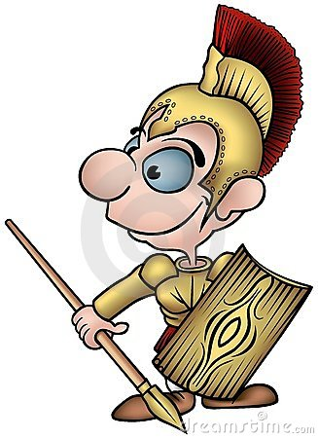 |  |  | 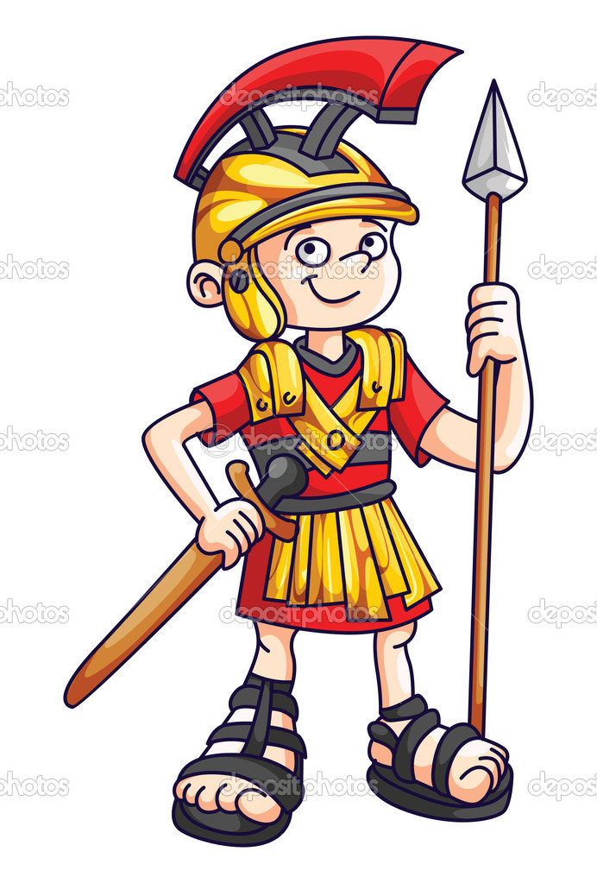
X | D | L | LXXX | CLX | M
CMXC | DCCXXX | XL | CDLXXX | CCXL | DCLXX
CCC | XC | CDXX | CCCLXXX | CDXL | CC

XX | DCCCLXX | CXX | LX | DCX | CM
CM | CCXX | CL | XC | LXXX | DCL
DLXX | CXC | CD | DCCLX | CCCLX | DCC

XXX | X | XX | XL | XXX | CC
LXXX | CDXC | CCLXXX | CCLXXX | CM | CCXXX
CXL | CCCXX | DC | DCCC | CL | LXXX

XXX | D | L | LXXX | CLX | M
CMXC | DCCXXX | LXXX | DLXXX | CXL | DLXX
CC | CLX | DXX | CCLXXX | CDXL | CCCXL

XL | DCCXX | CXX | LX | DCX | CM
CCC | CDXX | CL | XC | LXXX | DCL
CDLXX | CXC | CD | DCCLX | CDLX | CM

XL | LXXX | XX | XL | CXL | CC
DLXXX | DCCXC | DCLXXX | CCLXXX | CM | CDXX
CXL | CCCXX | DC | DCC | CL | LXXX

XL | D | L | LXXX | CCCXC | CM
CMXC | CCXX | DXL | CDLXXX | CCXL | DCLXX
CCCXX | XC | DXX | CCLXXX | CXL | CCX

LXX | DCCCXX | XC | CLX | CDX | CM
CM | CDXX | CLX | XC | CLXXX | DCL
DLXXX | CXC | CD | DCCLX | CCCLX | DCCX

CXC | CX | DXX | XL | XXX | CC
CLXXX | CXC | CLXXX | CCLXXX | CM | CXXX
CXL | CCXX | DC | DCCCX | CLX | CCLXXX

DCCLXXX | D | L | LXXX | CXC | M
CMXC | DCCXXX | XL | CDLXXX | CCXL | DCLXX
CCC | XC | CDXX | CCCLXXX | CDXL | CC

XX | LXX | CXX | CCLX | DCX | CM
CM | DCXX | CCLX | CXC | LXXX | DCLX
LXX | CDXC | DC | DCCLXX | CCCLXX | DCCX

CXXX | CCCX | CDXX | XL | XXX | CC
LXXX | DCXC | CLXXX | CCLXXX | CM | CDXC
CXL | CCXL | DCXL | DCCCXL | CLXX | CLXXX

CXXX | CD | CXL | CLXXX | CXC | CM
CMXC | CCXXX | XL | CDLXXX | CDX | DCLXX
CCCXX | DXC | DXX | CCLXXX | CDXL | DCC

XL | CCCLXX | DCXX | CLX | CDX | CM
CM | DCCXX | DCL | XC | CLXXX | DCL
DLXX | CXC | CDXX | DCLX | CCLX | DCCXX

XXX | X | XX | XL | CDXXX | CC
LXXX | CDXC | CCLXXX | CCLXXX | CM | CCCXXX
CXL | CCCXX | DC | DCCCX | CDL | CLXXX

